
Peking University HSBC Business School (PHBS)

PAO-BU-LIAO
A Smart Contract-based Management System for
Advance Receipts and Accounts Receivable.

Instructor: Professor Zeng HaiYang
Topic: Project Type 3

Group 2 (names in no specific order)
Ren Kai (任凯) | 2401212437
Zhang WeiJie (张伟杰) | 2401212474
Jiang YiMing (姜一鸣) | 2401212398
Hu Rui (胡瑞) | 2401212392
Lan Yang (兰杨) | 2401212401



Block Chain and Digital Currency
26th April 2025

1. Introduction
“Pay First, Use Later” and “Use First, Pay Later” are two common business models in everyday life, where there is a time lag between the receipt of cash and the occurrence of services. This creates problems in managing the buyer's Advance Receipts and the seller's Accounts Receivable, as shown in Figure 1.1. Under the traditional payment system, these problems are based on a plain trust between buyer and seller, which is often not sturdy and runaways are always occurring. As shown in Figures 1.2 and 1.3, the number and amount of runaway cases in gyms, coffee shops and milk tea stores, which are represented by rechargeable membership cards, have been increasing yearly in recent days. But the recovery rate of arrears averaged less than 20 percent!
The essential reason for this phenomenon is that under the traditional payment model, the flow of funds is untraceable and can be used arbitrarily. In this semester's course, we gained an in-depth understanding of how smart contracts work. Taking into account the advantages of their non-tamperability, they can therefore be used to develop management tools for advance receipts and accounts receivable that can truly record the flow of cash, which is the application that will ultimately be presented in this project - Paobuliao.
As the project framework in Figure 1.3, we will describe the business construction in detail in Part 2, show the technical implementation in Part 3, and draw a conclusion in Part 4.

2. Business Construction
In essence, Paobuliao is a smart contract-based online transaction platform. The overall framework is shown in Figure 2.1. It supports 2 transaction models: Use First, Pay Later and Pay First, Use Later. The platform covers 4 core operational scenarios: Verification, Contract Establishment, Daily Consumption, and Contract Termination. It is designed to effectively address real-world issues where sellers abscond with prepaid funds after buyers purchase stored-value cards.
To ensure logical clarity, this report will primarily focus on the Pay First, Use Later model. A brief explanation of the Use First, Pay Later model will be provided at the end.

2.1 User Registration and Identity Verification
Both buyers and sellers must register before using the platform. To ensure a one-to-one correspondence between users and accounts, buyers are required to submit biometric information (e.g., fingerprints or iris data) during registration, while sellers must provide valid business qualifications (Figure 2.2). These identity materials are encrypted using the user's private key and uploaded to the smart contract for account creation. After onboarding, sellers may publish and update their available service offerings on the platform for buyers to browse and contract.

2.2 Contract Establishment and Daily Consumption
When a buyer decides to purchase a stored-value card for a particular service, they initiate a Contract Establishment Request to the smart contract. Upon approval, the designated funds are transferred from the buyer’s account into a dedicated escrow account managed by the smart contract (Figure 2.3). This step corresponds to the real-world process of purchasing a stored-value card, but importantly, the funds are not immediately transferred to the seller.
Following this, the buyer may consume services based on the contract terms and their remaining balance. Payments to the seller are disbursed incrementally from the buyer’s balance as services are rendered (Figure 2.4).

2.3 Contract Termination
If the buyer submits a Contract Termination Request to the smart contract. Upon receiving the request, the smart contract notifies the seller and initiates the refund process, returning the remaining balance to the buyer (Figure 2.5). On the other hand, if the seller absconds, the contract will be terminated automatically. The system identifies seller default through two mechanisms. About Active Recognition, the smart contract regularly verifies the validity of the seller’s business qualifications. If the qualification is found to be revoked, the contract is immediately terminated and the remaining buyer balance is refunded. About Passive Recognition, buyers are allowed to report seller misconduct through the platform. If the number of complaints exceeds a defined threshold, the system determines that the seller has defaulted, and the buyer's remaining funds are refunded accordingly (Figure 2.6).

2.4 Use First, Pay Later Model
The Use First, Pay Later model differs mainly in that the buyer does not deposit funds into the smart contract in advance. Instead, service fees are settled periodically (e.g., monthly or annually), and there is a risk of buyer default. However, since each buyer account is bound to their biometric information, legal accountability can be more easily pursued in the case of non-payment. Additionally, unlike the Pay First, Use Later model, no refunds are involved upon contract termination in this case.

3. Technical Implementation
3.1 Implementation Logic
This system is designed around two payment models: “Pay First, User Later” and “Use First, Pay Later”. Corresponding smart contract frameworks have been developed for each model. A centralized Manager Contract is implemented to monitor and regulate user behavior and merchant operations, ensuring transaction security and compliance. The technical framework is illustrated in Figure 3.1. And we will explain them step by step.
3.1.1 Core Contract Structure
The system of Paobuliao consists of the following four main contract modules:
- Accounts Receivable Contract (Use First, Pay Later): Record the user's pending debt (pendingDebt) and enable settlement and seller balance updates by payDebt() function.
- Advance Receipts Contract (Pay First, User Later): Freeze user funds in advance via deposit() to ensure cash availability. The consume() function completes the consumption.
- Manager Contract: Executes user and merchant credit assessments and violation penalties using a combination of periodic checks and event-driven mechanisms.
- Record Contract: Serves as the system’s database, storing key information such as user identity, public keys, balances, and merchant qualifications.
3.1.2 Account and Identity Authentication Mechanism
To ensure secure and reliable participation in the system, both buyers and merchants must undergo a standardized identity authentication process.
Buyer Registration Process: Buyers complete identity verification either through biometric data or by generating a cryptographic key pair. Upon successful verification, the system stores relevant user information, including userId, public key, and initial balance.
Merchant Registration Process: Merchants are required to upload qualification documents and generate a key pair. After verification, the system stores their information in the SellerInfo struct, which includes the merchantId, a hash of the qualification documents, the merchant’s public key, and current status.
3.1.3 Consumption and Payment Logic
The system supports two distinct transaction models — Use First, Pay Later and Pay First, Use Later — each with tailored contract logic to ensure smooth and secure payment execution.
Use First, Pay Later Flow
- consume(userId, amount): The consumption amount is added to the buyer’s pendingDebt.
- payDebt(userId, amount): The function verifies that the repayment amount does not exceed the pending debt. Upon successful payment, both the pendingDebt and the corresponding sellerBalance are updated accordingly.
Pay First, Use Later Flow
- deposit(userId, amount): Before consumption, the user deposits funds, which are deducted from their available balance and frozen to guarantee future payment.
- consume(userId, amount): The system checks if the frozen funds are sufficient; if validated, the amount is transferred to the seller to complete the transaction.
3.1.4 Credit Scoring Mechanism
To encourage responsible behavior and maintain the integrity of the platform, a dynamic credit scoring system is applied to both buyers and merchants.
- Buyer Score: If a buyer fails to repay their pendingDebt within the designated timeframe, their credit score will be reduced accordingly.
- Merchant Score: Negative reviews or frequent complaints will negatively impact a merchant’s credit score.
Should any participant's credit score fall below a defined threshold, the system may trigger smart contract restrictions, such as account suspension or temporary trading bans. This scoring mechanism serves as a deterrent against misconduct and promotes trust and fairness.
3.1.5 Contract Termination Mechanism
To ensure contract lifecycle management and mitigate risk, the system incorporates multiple termination scenarios:
- Voluntary Termination by User: Users may choose to terminate their contracts, but must accept penalties as outlined in the contract terms. The Manager Contract will automatically execute the termination and enforcement process.
- Automatic Termination upon Contract Expiry: Contracts will be automatically closed once they reach their expiration date.
- Merchant Violation or Exit: If a merchant is found to be acting maliciously, such as receiving a complaint rate over 60% or being flagged for abnormal behavior, the Manager Contract will deactivate or revoke their account to protect users.
This multi-faceted termination mechanism ensures that the system remains orderly, secure, and responsive to both voluntary exits and misconduct.

3.2 Demonstration
The mobile interface was built using Vue.js, Vite, and CSS, ensuring fast performance and a responsive, user-friendly layout. As illustrated in Fig 3.2, the registration interface supports both users and merchants (via biometric data and business license uploads). Fig 3.3 shows the main page, offering quick access to contract-related features. Users can initiate and confirm smart contracts through Fig 3.4, with successful creation displayed in Fig 3.5, Fig 3.6 presents a daily consumption subpage that showcases real-time transaction progress, payment statuses, and smart contract execution stages, while Fig 3.7 handles contract termination, indicating user or merchant-initiated exits. Finally, Fig 3.8 displays transaction data observed from the backend, ensuring transparency and traceability.

4. Conclusion & Extension
This project proposes Paobuliao, a decentralized service platform that addresses trust issues in prepaid and postpaid contractual agreements through the integration of cryptographic technologies, smart contracts, and community governance. To solve common market failures, such as merchant fraud, user default, and lack of legal recourse in low-value service transactions, Paobuliao introduces a novel framework with both technological depth and practical usability. The key technical innovations include:
- Biometric Identity + Public Key Encryption
- Dual Contract Modes (“Pay Before” & “Pay After”)
- On-Chain Penalty Enforcement
- Community-Powered Merchant Exit Detection
The technological design of Paobuliao not only resolves long-standing trust issues in service-based economies but also introduces a scalable, programmable trust protocol that can generalize across industries. It demonstrates how smart contracts can enforce nuanced behaviors like conditional payments, penalty rules, and consensus-based contract termination.
Furthermore, by embedding identity verification and governance logic into the protocol itself, the system reduces reliance on third-party arbitration and opens possibilities for jurisdiction-light, self-enforcing agreements.
In a market often plagued by unreliable prepayment practices and enforcement asymmetry, Paobuliao offers a blueprint for restoring balance. It redefines how trust is built, enforced, and visualized — particularly in sectors underserved by traditional legal frameworks. From both a design and systems perspective, this project showcases how combining biometric identity, smart contracts, and community mechanisms can lead to more equitable digital service environments.

Appendix

Figure 1.1 Runaway dilemma of “Pay First, Use Later” and “Use First, Pay Later” business models.

Fig 1.2 Statistics on Prepaid GYM Run Away.

Fig 1.3 Statistics on Prepaid Coffee & Milk Tea Shop Run Away.

Fig 1.4 The framework of our project.

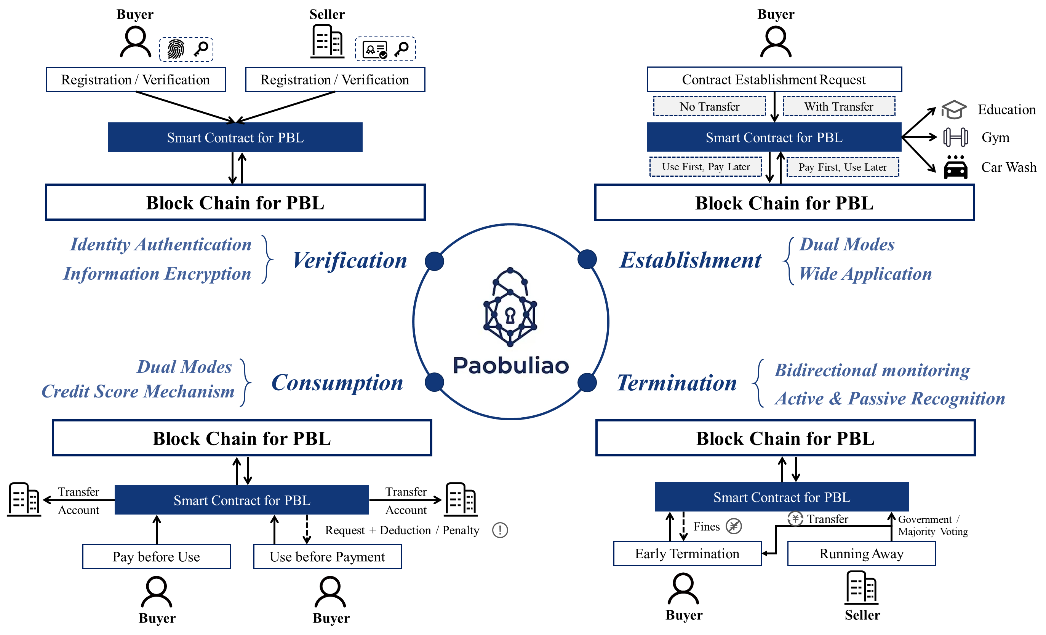
Fig 2.1 The overall framework business construction.

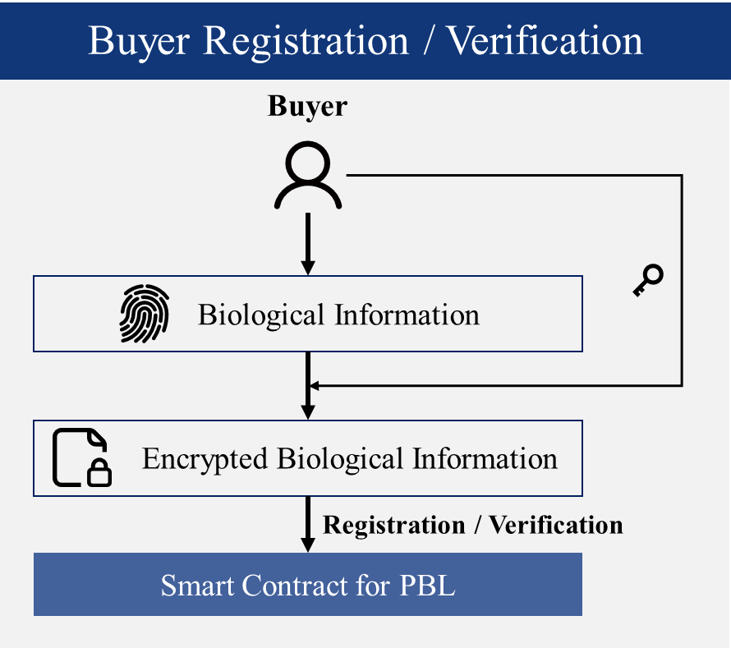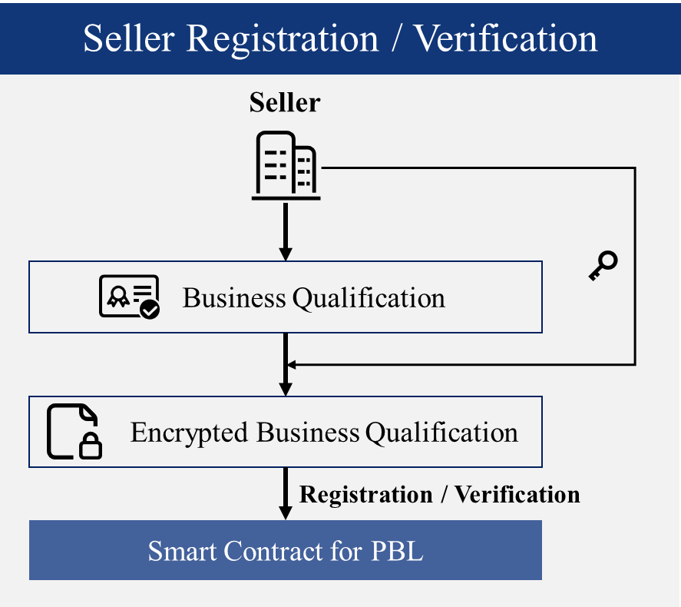
Fig 2.2 The logic of registration process of buyer and seller.
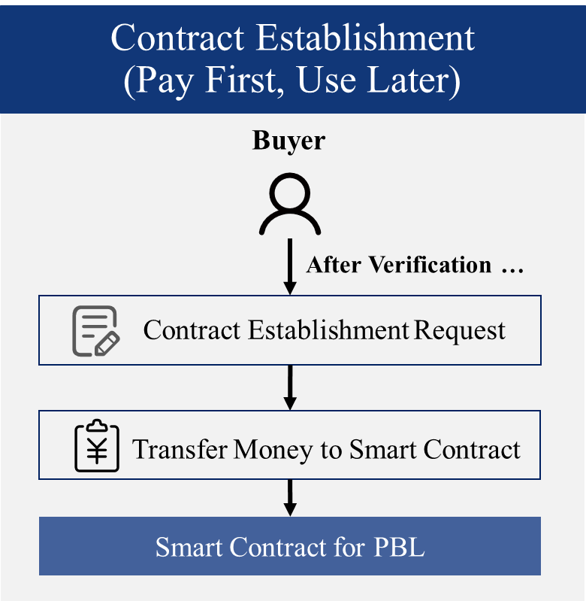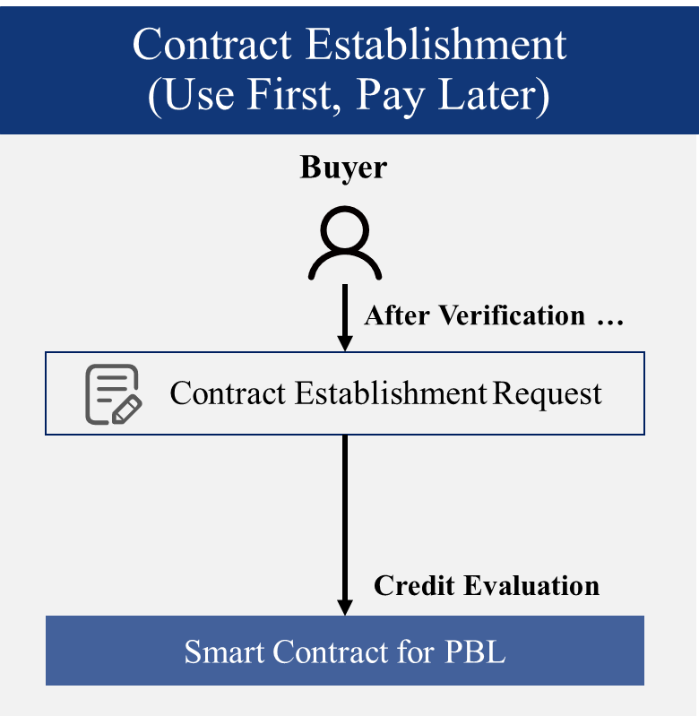
Fig 2.3 The logic of contract establishment process.
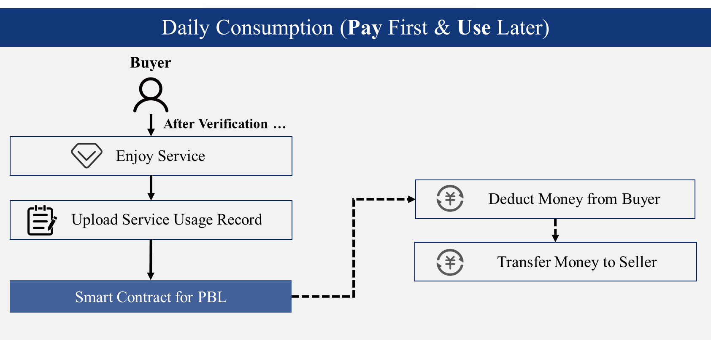
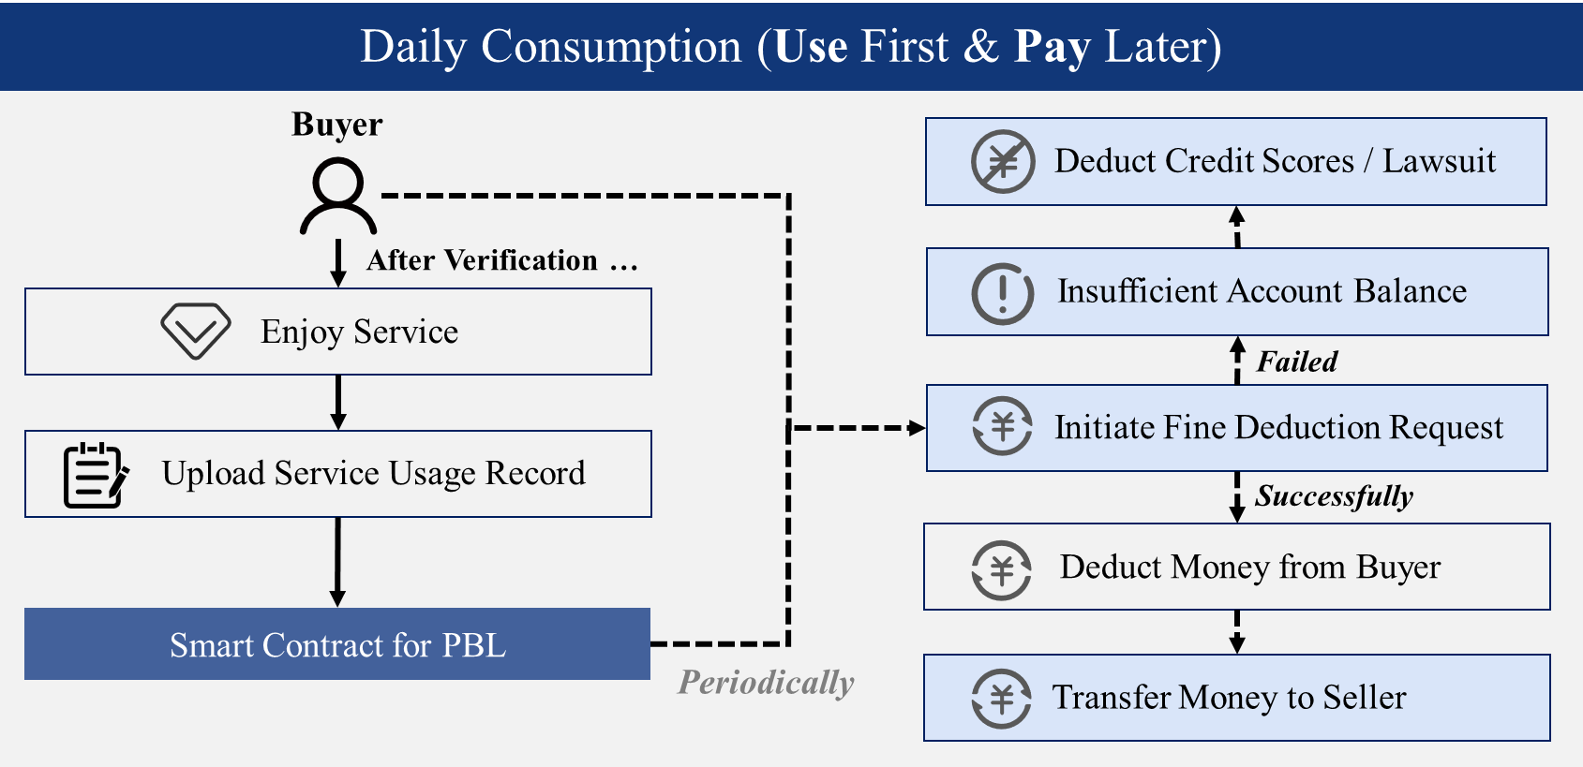
Fig 2.4 The logic of daily consumption process.

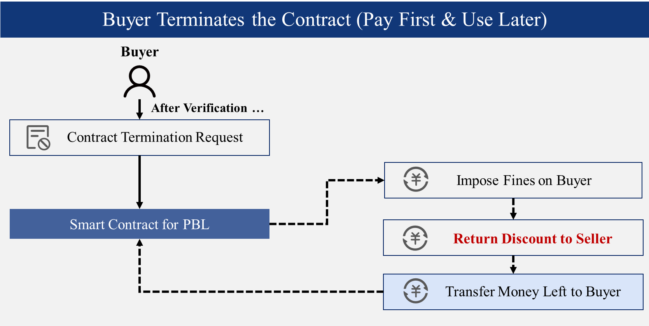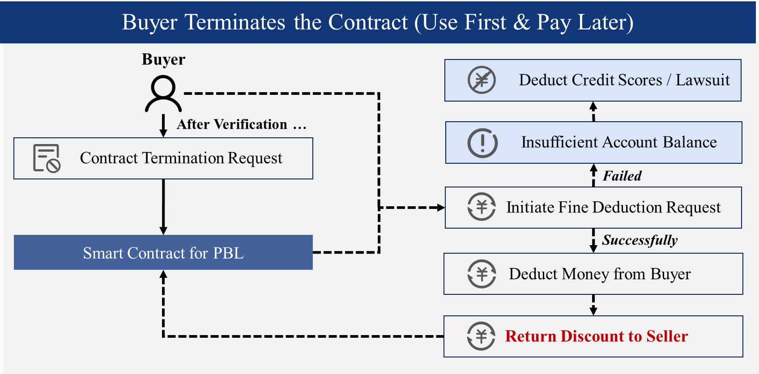
Fig 2.5 The logic of contract termination process (initiated by buyer).
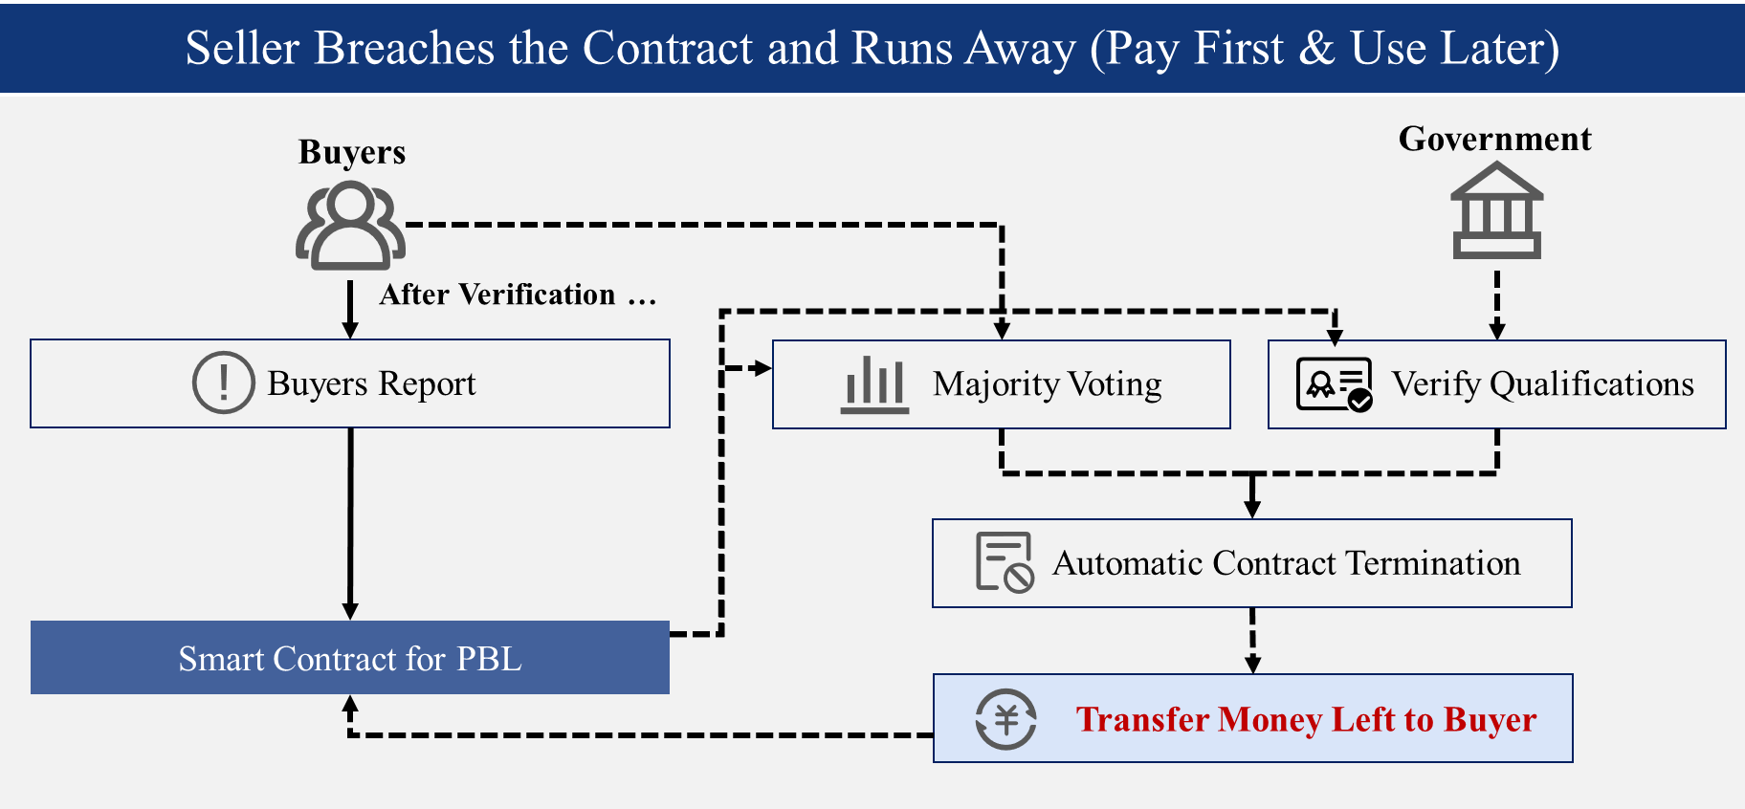
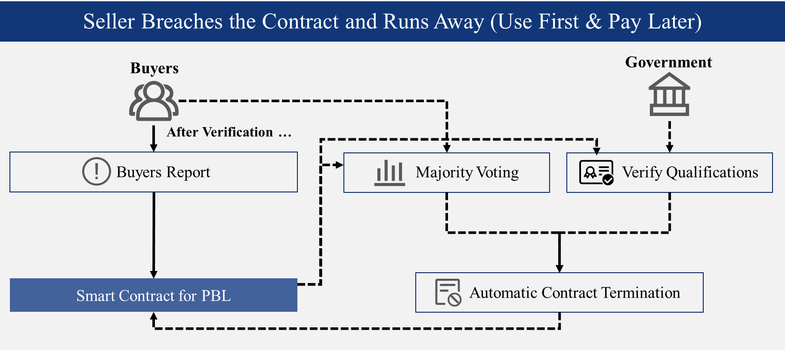
Fig 2.6 The logic of contract termination process (initiated by seller).

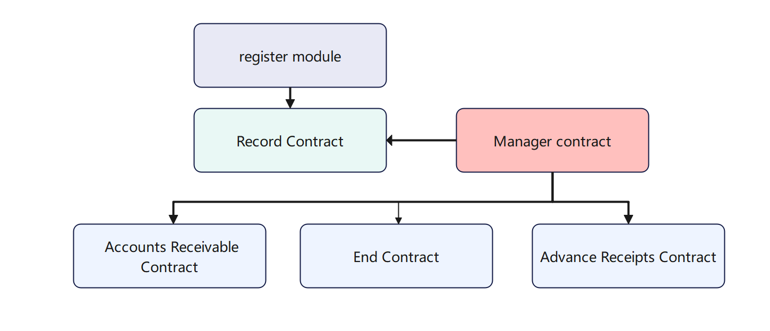
Fig 3.1 The framework of implementation logic.

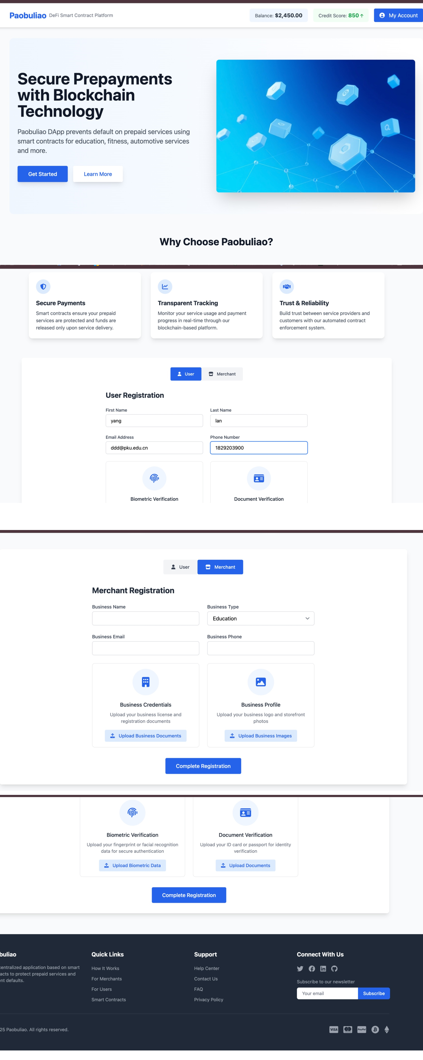
Fig 3.2 The interface for registration(Buyers/Sellers).
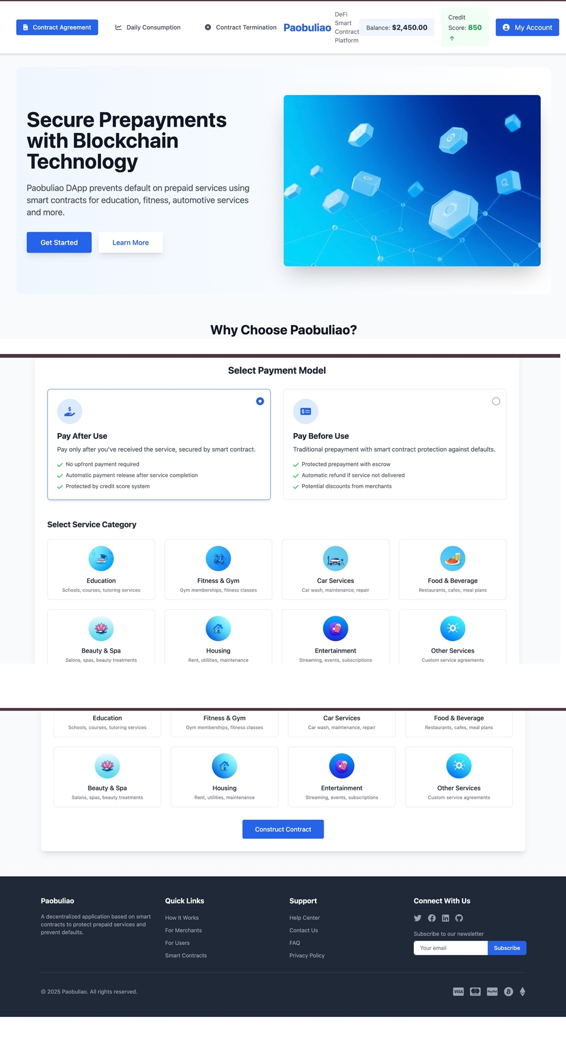
Fig 3.3 The interface for main page.

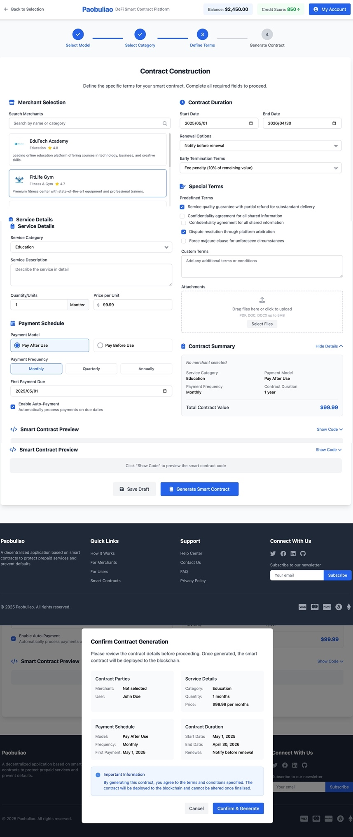
Fig 3.4 The Interface for contract creation & confirmation.
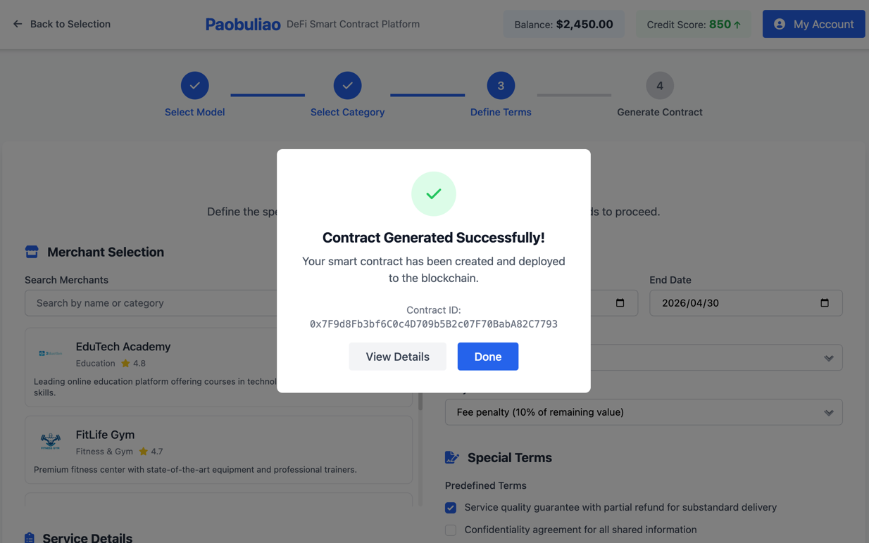
Fig 3.5 The Interface for contract success generation.

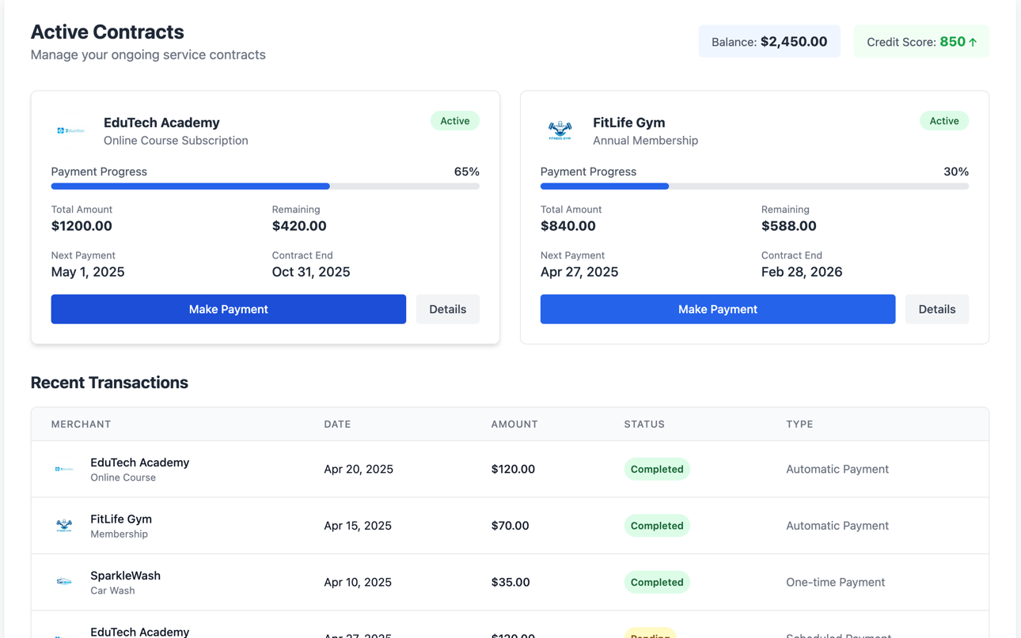
Fig 3.6 The Interface for subpage-daily consumption.

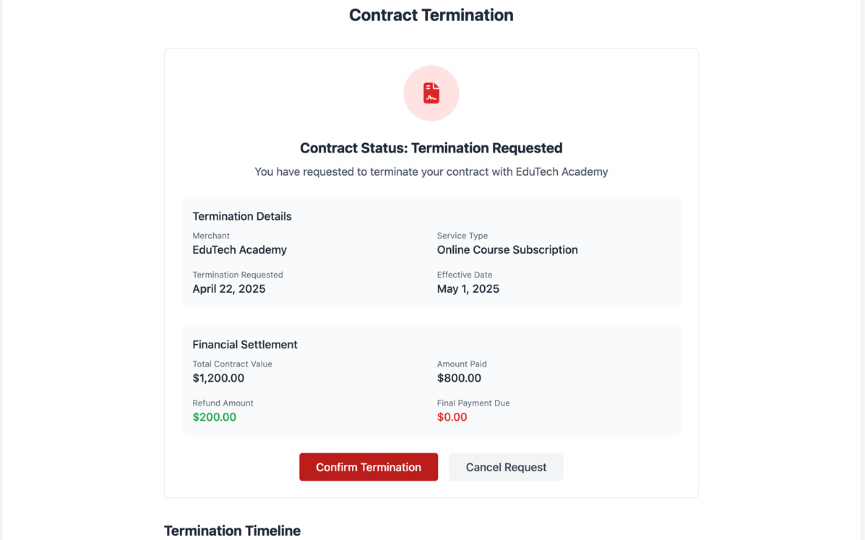
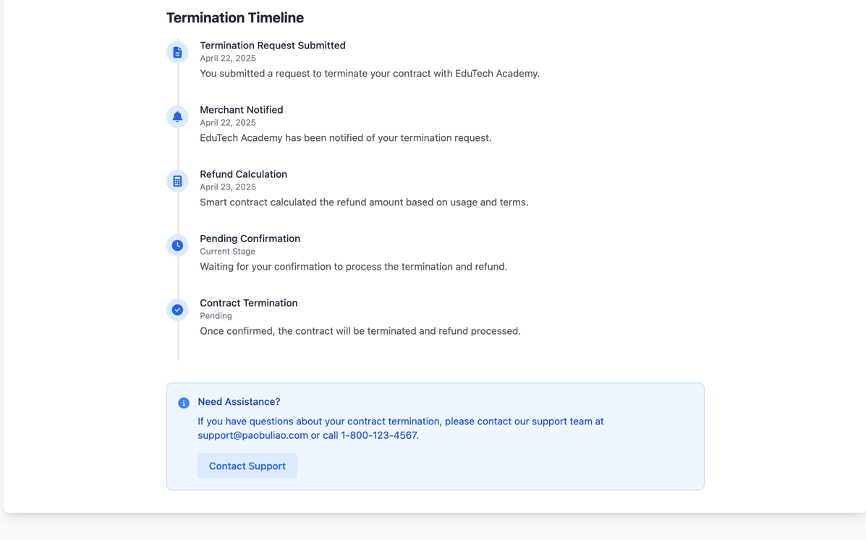
Fig 3.7 The Interface for subpage-contract termination.
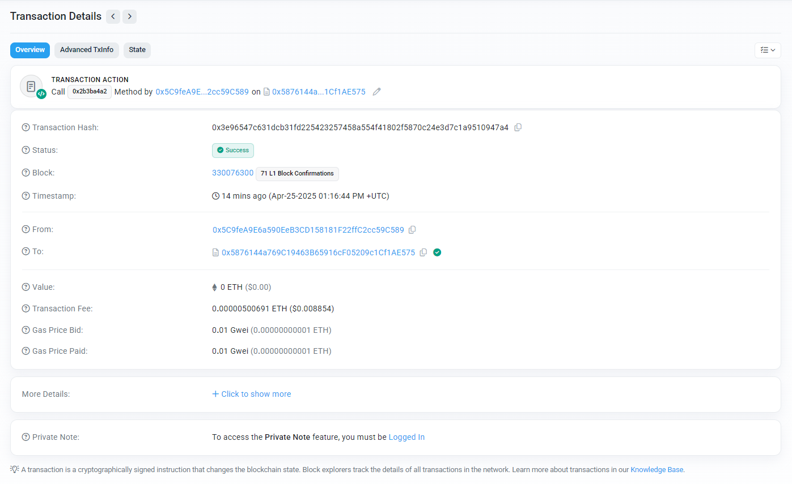
Fig 3.8 The transaction details of a contract.

